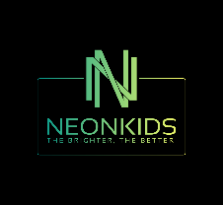
Neonkids VIP Membership application form

🔹 Personal Information
Full Name:

Email Address:

Phone Number:
Address:

🔹 Membership Details
Choose your VIP Membership plan:
⬜ 1 Year – CHF 30
⬜ 2 Years – CHF 50
Additional Name (optional – one person only, e.g., spouse):
(This name will be included on your VIP e-card)

🔹 Agreement & Terms
Please read and agree to the following:
- ⬜ I understand that the VIP Membership discount cannot be combined with other ongoing promotions.
- ⬜ I agree that the VIP code is non-transferable and only valid for the person(s) named above.
- ⬜ I understand that Neonkids reserves the right to terminate the membership if the code is used by unauthorized individuals.
- ⬜ I acknowledge that the VIP Membership fee is non-refundable.
- ⬜ I understand that VIP benefits start once payment is completed.
Signature:

Date:

✅ Payment Information
Payment can be completed via:
- Online checkout at: www.neonkids.store
Once payment is confirmed and this application form is sent to: support@neonkids.store , you will receive your personalized VIP Membership e-card via email within 24–48 hours.

